Email etiquette

Make your email more professional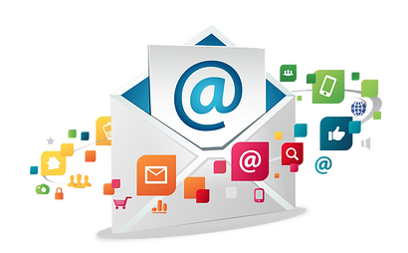

Many of us tend to ignore the importance of communication via email. It is treated just as another channel of communication. However, we cannot deny that the subject line, content, tone of communication plays a vital role in conveying our message via email.

- Draft the content of the email
- Use bullet points and short sentences to convey your message
- Content should be crisp, thorough and non-iterative
- Highlight key points like Date, Cost, Venue etc.
- Ensure the tone of your message is correct
- Spell check your content
- For very important mails get a proof reading done
- Avoid sending confidential communication via email
- Be respectful while writing and email
- Do not add heave attachments in email. If possible share the path of documents instead of attaching it in emails
- Chose the correct Subject Line – The Subject Line should be able to communicate the purpose of email
- Recipient’s email list
- This should be put at the end, after content is drafted, reviewed and finalized
- Get the correct email id of the audience
- The main audience should be in “To” list of recipients
- Rest of audience who should be informed will be in “Cc” list
- When you reply to an email, ensure that you update the Subject of the response
- Create an email signature containing your contact details for recipients to reach out to the sender

