Effective Presentation Skills for a Project Manager

In addition to knowledge related to process, technology and domain, Project Managers should have additional skills like good communication, leadership capabilities, presentation skills etc. I had once worked with a Project Manager who struggled during the monthly status presentation to senior leadership. His presentation content was impressive but he struggled communicating during the presentation. So, what are some of things we should take care of during a presentation:

- Come prepared for the presentation – It is important for you to be well prepared. You have to understand what are you presenting. Are you presenting about the overall project health, are you sharing budget related information or are you sharing competitor best practices, prepare you self with adequate data? Practice makes a person perfect, so rehearse your presentation, preferably do a dry run with a co-worker and time your presentation
- Come early and set up the infrastructure – Often times we end up having technical glitches midway during the presentation. To avoid that, we should come in early ensure the infrastructure is up and running
- Understand the audience expectation. I normally use first 5 minutes to break the ice. If you are nervous, you can use this 5 minutes to connect with the audience and make them comfortable and shake off your nervousness
- Keep the content simple, brief and data driven – do not make text heavy presentations, concentrate on the key message. The average attention span of an audience on each slide is around 5-7 minutes, so keep the slides light on content and speak more

This is a tip from Guy Kawasaki of Apple. He suggests in “The 10/20/30 Rule of Powerpoint” hat slideshows should:
  - Contain no more than 10 slides
  - Last no more than 20 minutes
  - Use a font size of no less than 30 point

- Effective usage of voice and body language – A good presenter knows how effectively he/she should utilize vocal nuance and body language

- Hiding your hand, fiddling with your hands or any object are signs of nervousness
- Crossing your arm is a defensive posture. A client had once pointed out to a team member of mine that a presenter with close arms does not appear to be welcoming
- Eye contact with the audience is important
- A smile on the face and a positive attitude makes the presenter more approachable
- Ask few questions to the audience to keep the session interactive

A good reference: Seven Tips for Effective Body Language on Stage

- Infographics on slides help to connect with audience
There is an increase in trend in using infographics in presentation these days. People who work in the UI/UX world are very familiar with this term. Infographics are visual representation of data. When we want to explain multiple complex data to the audience, it is easier to explain it visually through a combination of image, graph and text. Infographics augment textual content and translates complex information to a simple story that can be easily interpreted by the audience

Click here for a good example of a presentation using infographics effectively

- Engage the audience through effective story telling – Every time I prepare for a presentation, the first thing that comes to my mind is what is the story I am trying to communicate. What should be the beginning – middle –end of my story. I structure my presentation in the form of a hamburger story template taught to me in my elementary school. I would also use lot of examples to keep my audience engaged.

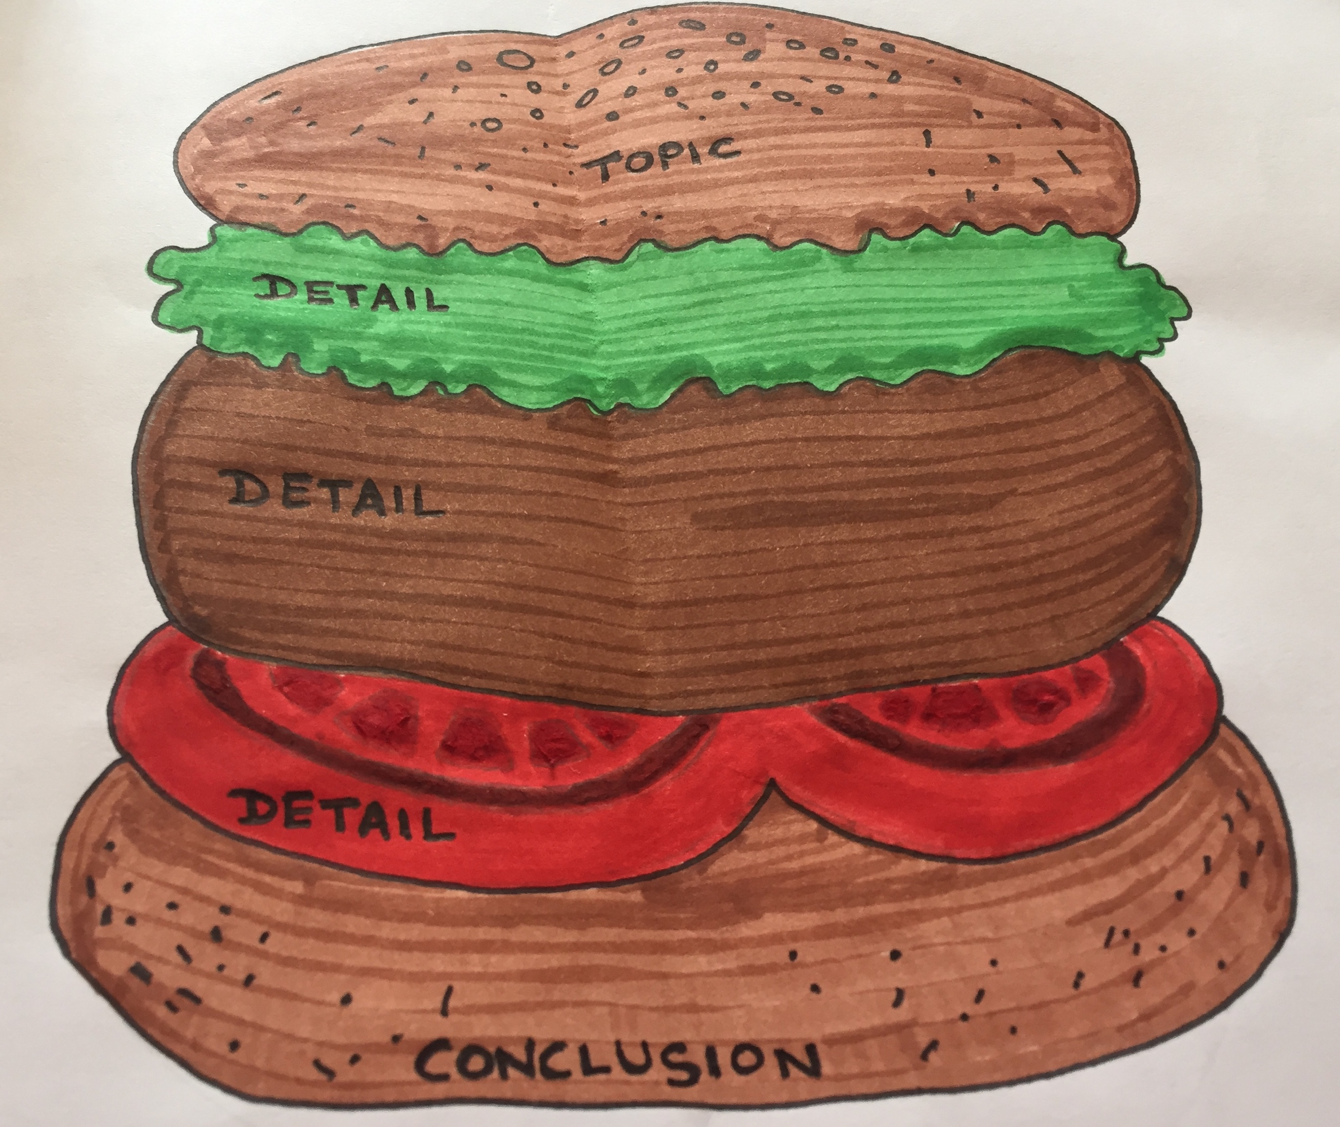

Presentation skills does not come naturally to many people. The eloquence with which we speak differs from one person to the other. However, we can work on it, bring in the positive attitude of improvement, be enthusiastic about what we present. Be confident about what we present. No one knows the content better than us, so take a deep breath, smile and carry on.

We might not have the answers to all questions that may come from the audience, it is ok to say “I do not have an answer to this but I shall get back to you. “
So, all of us should apply Eleanor Roosevelt's maxim that "No-one can intimidate me without my permission".

I hope the above tips will help those of you who are interested to polish their presentation skills.

References:

Inc. Magazine's Guide to Communication Skills: https://www.inc.com/guides/growth/23032.html

Guy Kawasaki: The 10/20/30 Rule of PowerPoint https://guykawasaki.com/the_102030_rule/
If you are interested to improve your communication skills further, reach out to your local public speaking club through toastmasters International: http://www.toastmasters.org/

